Councillor’s Monthly Bulletin – August/September 2022
from Maurice Cook and Lydia Freeman
(Please circulate electronically and print only when necessary. We should be most grateful for our bulletin to be posted on your websites for the benefit of your residents.)

Ward News
Update on Katch Bus service.

We have been pressing for information on the uptake of this service and have now, via the auspices of the Framlingham and Wickham Market Community Partnership, met with County Officers and received a copy of a report is to be presented to Suffolk County Council Cabinet.

The first 60 weeks of operation included interruptions for Covid restrictions but, nevertheless some 5,881 passengers used the service of which 1,754 were children.
2,030 journeys were booked via the app and 2,475 by telephone.
There were 3,774 single journeys and 2,107 return journeys booked.
The highest number of bookings were for the journey from Bridge Street, Framlingham to Wickham Market Rail station.
The review evidenced that demand for the service was:
low between the hours 10.00 to 14.00.
Minimal to zero demand during the hours 06.30 to 08.00 & 20.00 to 22.30.
Minimal to zero demand for the service on Sundays.
There was evidence that children were using the service to get to school.

The Katch service is one of a number of community schemes now operating in the District and there are positive signs that, with further investment and consideration of expanding the number of stops en-route, this service can be a valuable asset to the Framlingham Ward community.
The Hour Community is conducting a feasibility study to see how might extend the use of their 13-seat minibus. One suggestion has been to see how much take up there would be if they provided a weekly service for the older members of the communities, with or without mobility issues, from surrounding Parishes to Framlingham and back again.
Robert Burgess of the \hour Community would be happy to meet with you to discuss this further if you wished.
www.hourcommunity.co.uk
07785231294

District News
Chief Executive to retire after 17 years at the helm of East Suffolk Council
East Suffolk Council’s long-serving Chief Executive, Stephen Baker, has announced that he is to retire.  After a career in local government spanning four decades, culminating in 17 years at the helm of East Suffolk and its predecessor councils, Stephen will step down from his post at the end of this year. | 
As Chief Executive of the biggest district council in the country by population, Stephen has been at the forefront of local government innovation, becoming one of the country’s first ever joint Chief Executives when taking up the reins at Waveney District Council alongside his role at Suffolk Coastal.

He then oversaw more than a decade of successful, cutting-edge partnership working, culminating in the creation of East Suffolk Council, delivering the best possible services for local people. His experience and sage advice have been instrumental in making East Suffolk into an outstanding place to live, work, and visit. He can be incredibly proud of his achievements throughout his career, and he will be missed by the whole team.

To ensure a smooth transition, recruitment for a new Chief Executive is now underway, with the council looking to make an appointment in the autumn.

Bold new beach huts officially opened on Lowestoft’s seafront
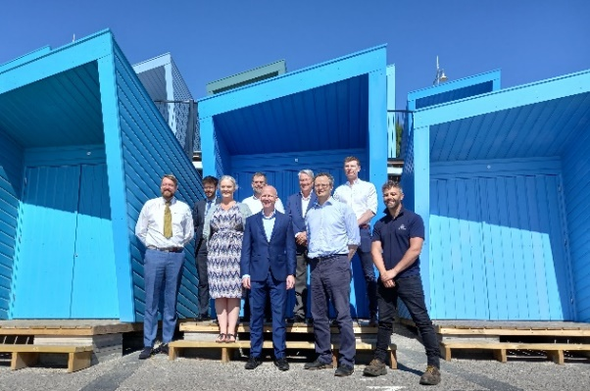 | As part of ambitious plans to enhance Lowestoft and help the town gain further recognition as a visitor destination, 72 striking new beach huts are now officially open.  The contemporary beach huts, known as Eastern Edge, have been built on the site of the former Jubilee Terrace huts on Lowestoft’s seafront.

Work began in September 2021, with the huts designed by Norwich-based architects Chaplin Farrant and manufactured by Lowestoft-based PJ Spillings, and the platform, hut installation and ancillary works undertaken by M S Oakes – also from the town.

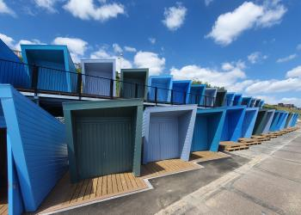 | Local residents and visitors have been enjoying the striking new beach huts and community groups are also getting involved.  Organisations are able to hire one of the huts for a community event or special get-together, with some huts able to be linked together, by arrangement, for groups needing a larger accessible space.
Disability Advice North East Suffolk recently held a beach day at one of the accessible Eastern Edge huts – another of which was sponsored by Southwold-based Adnams and made available to local residents through the company’s Community Heroes project, which acknowledged individuals and organisations that made a difference in their communities during the pandemic.

As part of the Adnams sponsorship, Suffolk Libraries held a week of free events in a pop-up beach library, including a children’s book giveaway, colouring and storytelling.

Free meals and summer holiday activities for schoolchildren
Numerous organisations have signed up to provide fun and food as part of a programme of experiences for children and young people over the coming weeks.

The Holiday Activities and Food (HAF) programme is funded by the Department for Education through an annual budget from Suffolk County Council.

The local programme is targeted at those eligible for benefits-related free school meals, and other vulnerable children, or those with additional need, that would benefit from accessing the programme.

Local authorities have discretion to use up to 15% of funding to provide free or subsidised holiday club places for children who are not in receipt of benefits-related free school meals but who the local authority believe could benefit from HAF provision.

Among offerings are Operation Camouflage, organised by the Army Welfare Service and East Suffolk Council, at Sutton Heath, near Woodbridge, and sporting activities provided by leisure partner Everyone Active, in Lowestoft.

Helping East Suffolk ease the squeeze on cost of living
 | As the UK continues to face a cost-of-living crisis, households are seeing huge increases in their outgoings.  As we head into the colder months, East Suffolk Council has a responsibility to help residents find the support they need.
That is why we have launched Ease the Squeeze – a comprehensive scheme which helps connect those needing help to those helping.
We are working closely with key partners on a number of local schemes, while also directing people to other available support and services.
All the information, including practical support, funding and advice, has been gathered on our website, at www.eastsuffolk.gov.uk/squeeze. This page is continuously being updated as more schemes, services and support becomes available, so please share this with others.
We will also be running a social media campaign to raise awareness of the website.
Customer Services, Communities and Housing are working closely together to provide a wide range of support and advice.

Nicole Rickard, Head of Communities, will host live online information sessions about Ease the Squeeze, on Teams, from 11.30am-12.30pm on Tuesday 6 September and from 4pm-5pm Wednesday 14 September. Email Joanna.jonas@eastsuffolk.gov.uk to book a spot.

£24.9million regeneration programme given final go-ahead for Lowestoft
A £24.9m programme to transform Lowestoft has received final Government approval, enabling work to progress on five major regeneration projects.  In 2019, Lowestoft was one of 100 towns invited by the Department for Levelling Up to develop a bid for up to £25m of the £3.6bn Towns Fund. | 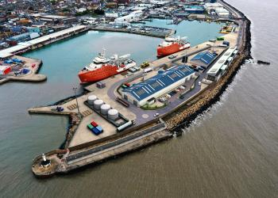
The Lowestoft Town Investment Plan, developed alongside the Lowestoft Place Board, setting out the ambitions, opportunities and challenges of the next 10 years, was submitted to the Government in 2020 as the basis of a £24.9m application, focusing on five projects:

The Station Quarter: Full restoration of the former Post Office and front of Lowestoft railway station building.
The Cultural Quarter: Improvements to the Marina Theatre, redevelopment of the East Suffolk Council’s current Customer Services Centre to provide a new cultural facility, and redevelopment of the former Battery Green multi-storey car park to provide a new leisure offer.
The Historic Quarter: Redevelopment and refurbishment of the Town Hall, along with enhancing the historic ‘Scores’.
The Seafront Vision: Redevelopment of Royal Plain, including the Royal Plain fountains, Royal Green and associated public realm to complement the recently refurbished East Point Pavilion.
The Port Gateway project: Supporting development of the Lowestoft Eastern Energy Facility (LEEF) to secure Lowestoft’s future as an Operations and Maintenance hub for the offshore renewables sector.

Full funding was provisionally secured in March 2021 before detailed businesses cases were submitted for each of the five projects in March 2022.

Businesses and visitors will be able to view proposed designs and learn more about each project in the coming months, with all five projects having now received final approval and due for completion by March 2026.

Free Wi-Fi programme expands to another two East Suffolk towns
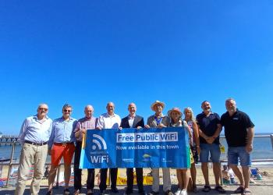 | Free-to-use public Wi-Fi has now been launched in Southwold and Woodbridge following recent launches in Felixstowe and Lowestoft and as part of a range of exciting digital projects.  To support local towns and businesses, East Suffolk Council is delivering a range of digital projects which aim to strengthen the local economy and improve connectivity within the district’s market towns.

One of these projects is the East Suffolk Digital Towns programme, which will digitally transform market towns through the installation of free public Wi-Fi, digital footfall counters and town marketing platforms alongside a business support programme. It was initially piloted in Framlingham in 2019.

Supported by funding from the Getting Building Fund and New Anglia Local Enterprise Partnership’s Innovative Projects fund, this new technology will be combined with bespoke business support, helping local businesses and the towns in which they are based, to grow.

New technology will enable the Council to understand the number of visitors to the towns, the busiest periods, the average time people spend in the town centre and much more. This will enable the council’s Economic Development team to provide tailored support for local businesses and provide data-based evidence to support other ongoing projects.

We are also working in partnership with an interactive walking app provider, Go Jauntly, to develop outdoor adventures across all of East Suffolk’s principal 12 towns and villages.

Following these latest launches, East Suffolk Free Wi-Fi is provisionally scheduled to be available in Beccles, Bungay, Halesworth, Aldeburgh, Leiston and Saxmundham by October.

Renewable energy support hub project wins planning award
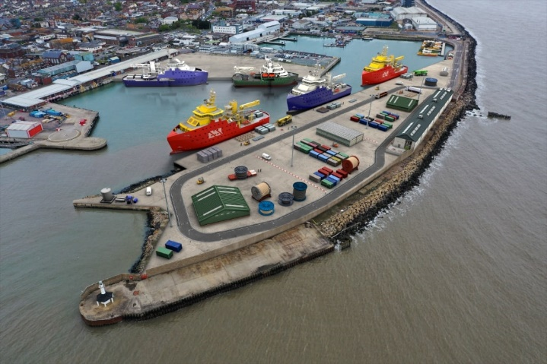 | A major planning project to support the offshore energy industry on the East Suffolk coast has been recognised as an outstanding example of partnership work.  The Lowestoft Eastern Energy Facility (LEEF) is designed to provide the infrastructure required to meet current and future industry demand. Once complete, it will allow the Port of Lowestoft’s Outer Harbour to accommodate the next generation of offshore support vessels.

A collaboration between East Suffolk Council as determining body and Associated British Ports (ABP) as applicant, the LEEF was named ‘Best Project’ at the regional final of the Royal Town Planning Institute (RTPI) Awards for Planning Excellence 2022.

Head of Planning and Coastal Management at ESC, Philip Ridley also came away from the ceremony having been Highly Commended in the Head Planner of the Year category.

Meanwhile, the Chair's Award, presented to an individual who has gone above and beyond expectations in providing support and mentoring within the planning industry, was posthumously presented to the late Lisa Chandler, who passed away earlier this year. Lisa was a much-loved colleague and highly regarded Energy Projects Manager in the Planning and Coastal Management Service.

Community celebrates opening of redesigned and modernised play area

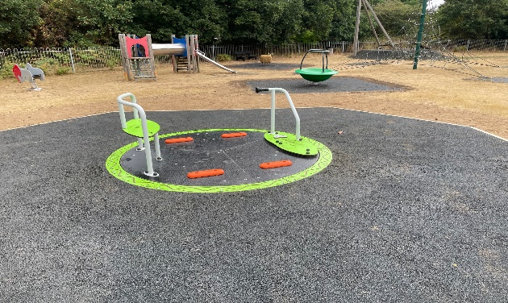 | An updated and improved play area has reopened to the local community that helped shape its new design.  Among many new features, the play area in Purdis Farm now includes seating and sculpture based on clay models handcrafted by local youngsters.
Funded through East Suffolk Council’s Outdoor Playing Space Fund, the redevelopment of the Murrills Park play area has been a community effort from as early as its inception.

In the summer of 2020, East Suffolk Council consulted residents of Purdis Farm for their views on how to spend available funds for 'sports and active play' from the Outdoor Playing Space Fund for Parishes. The responses helped to create a tender – awarded to successful bidder, Groundwork East, ahead of a series of community events earlier this year to give residents an opportunity to see the new designs and offer feedback.

Youngsters cast clay models which provided inspiration for the hare and bunny seating and the moon-gazing hare sculpture that now serve as way markers around the park – indicating an existing walking route and information boards about the area.

The park also now boasts a new accessible roundabout, part funded by county councillor Patti Mulcahy, along with a new circular group swing, a wobble sheep, and five new pieces of outdoor gym equipment.

Charity cycling event returns to East Suffolk
A popular cycling event is set to return to East Suffolk following a two-year break brought on by the pandemic.
The first Women on Wheels (WOW) event in the district since 2019 will set off from Ipswich School Sports Centre, in Rushmere St Andrew, on Sunday 4 September.  The mass participation, female-only events focus strongly on the fun, friendly and inclusive aspects of cycling – with each ride featuring routes of an achievable distance for any level of ability and experience. | 
Any profit from entry fees for the ride, organised by East Suffolk Council and Plomesgate Cycling Club, will be shared between two nominated charities, Lighthouse Women’s Aid and Fresh Start new beginnings.

'Efficient, clean and super green' refuse lorries hit the streets of East Suffolk
East Suffolk Council has welcomed the addition of 'efficient, clean and super green' biofuel-powered trucks to its fleet of refuse collection vehicles.  The arrival of the vehicles on the streets of East Suffolk is the latest move towards switching the entire fleet to eco-friendly fuel.  Last year, the Council approved plans to switch its diesel fleet to be fuelled by HVO (Hydrotreated Vegetable Oil) and reduce total carbon emissions by more than 30%. | 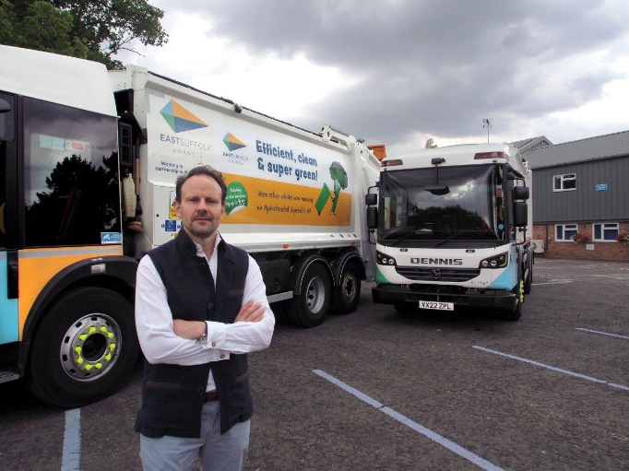
An advanced renewable and sustainable fuel, HVO offers up to 90% reduction in carbon emissions compared to diesel.

The 246-vehicle fleet, mainly operated by waste management partners East Suffolk Norse, was the biggest single contributor to the Council's carbon footprint last year. A third the vehicles will initially be converted to HVO, including 60% of heavy goods refuse lorries.

Communities team takes part in campaign to tackle anti-social behaviour
East Suffolk residents met representatives from the Council’s Communities team and Suffolk Constabulary as part of a national campaign to tackle anti-social behaviour.

Running from 18 to 22 July, ASB Awareness Week aimed to encourage communities to take a stand against anti-social behaviour (ASB) and highlight the actions that can be taken by those experiencing it.

Organised by Resolve, the UK’s leading ASB and community safety organisation, ASB Awareness Week featured a series of events across the UK involving councils, police forces, housing associations, charities, community groups and sports clubs.

Representatives from East Suffolk Council and Suffolk Constabulary visited towns across the district to speak to residents about tackling ASB in their communities and how to report it.

Suffolk town centres adjusting to living with COVID-19 this winter
To further boost town centre recovery, Suffolk Growth has awarded new grant support of over £60,000 to town centres across the county.

The 2022 Living with COVID-19 Town Centre Support Grant programme has been made available through the Covid Outbreak Management Fund (COMF), awarded by Suffolk Public Health. The grants have been awarded to projects which support good practice and activities that deliver ‘living with COVID-19’ approaches to reduce the potential spread of the virus this coming winter.

The successful projects, led by partnerships of town councils, local authorities and Business Improvement Districts, will take place this winter in Beccles, Bury St Edmunds, Clare, Hadleigh, Halesworth, Ipswich, Leiston, Mildenhall, Newmarket, Stowmarket and Sudbury.

Suffolk Growth is now working with these eleven towns across a range of projects to deliver more outdoor activities and safer spaces for socialising, events, town centre walking routes and guidance for residents and visitors on staying safe.

In November 2021, £40,000 was granted to nine towns from the COMF Towns Fund to support activity to prevent the spread of Covid-19.

Strategy for sustainable and inclusive future of leisure and sports facilities
This Council has renewed its commitment to improving the health and wellbeing of its residents by adopting a new strategy for leisure and sports provision.

The East Suffolk Leisure Strategy will help to ensure that the needs of the community are met by developing the provision of sport and physical activity across the district.

Key among the strategy’s will be to protect and enhance the existing supply of playing pitches and outdoor sports facilities where needed for meeting current and future demand.

The overarching strategy incorporates the Council’s Indoor and Built Sports Facilities Strategy (IBF), Playing Pitch and Outdoor Sport Strategy (PPOSS) and Open Space Report.

A total of 571 sports clubs responded consultation during the development stage of the documents, along with community groups, town and parish councils, schools, health partners and operators.

The resulting studies will prioritise areas most in need of improvement and identify ways to potentially improve existing shortfalls, while also helping the Council achieve its strategic objective of Enabling Communities by providing data that could assist with future funding bids for local improvements.

Bookable ‘Buzzabout’ bus service launches for villages north of Lowestoft
 | A new community transport service has been launched to help people living in the villages north of Lowestoft to get out and about more easily.  Operated by BACT and funded by East Suffolk Community Partnerships, Buzzabout is a new bookable bus service for residents in Gunton East, Somerleyton, Lound, Blundeston and St Olaves.
A 16-seat Buzzabout minibus can be booked on Mondays and Thursdays to pick people up and take them where they want to go, including into Lowestoft town centre, Somerleyton and Lowestoft railway stations, the local supermarket, or into other neighbouring villages.

East Suffolk’s Community Partnerships set up a Transport and Travel group to identify parts of the district lacking in rural transport and are working across East Suffolk to introduce new on-demand transport options.

Buzzabout fares are discounted until July 2023, with a return trip from Lound to Lowestoft just £4.

Hospital pressure-easing patient scheme wins national recognition
In innovative partnership scheme, delivered by East Suffolk Council to support hospital patients returning home from hospital, has been highly commended by national award judges.

Stepping Home was launched in 2018 as a way of recognising the impact of housing on the health, wellbeing and independence of communities, and to provide support for patients awaiting hospital discharge or at risk of admission.

A partnership covering the five Suffolk local authority areas, as well as the West Suffolk and East Suffolk Clinical Commissioning Group, Stepping Home launched as a pilot service but proved successful enough to be adopted permanently to support all agencies and service users.

Total estimated service savings, after running costs, are in the region of £404,220 – equivalent to almost 1,700 hospital bed days, 16 band five nurses, or 700 ambulance call-outs.

The service received high commendation from judges in the Health and Social Care category of the annual Local Government Chronicle (LGC) Awards at Grosvenor House, London.

Felixstowe's Seafront Gardens wins coveted Green Flag Award
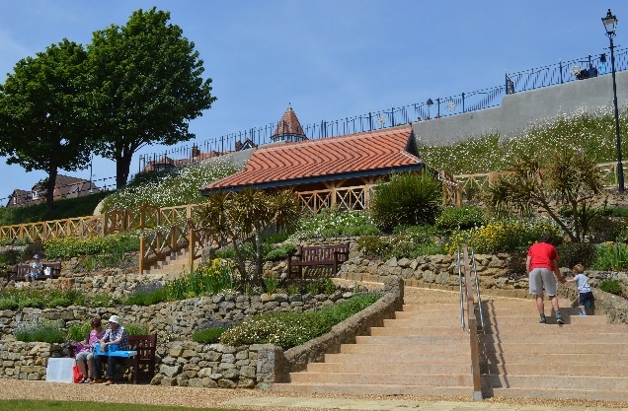 | Felixstowe's Seafront Gardens has once again been officially recognised as one of the country’s best parks after receiving a Green Flag Award.  The serene Victorian cliffside site was today awarded the international quality mark for parks and green spaces for the seventh successive year.
This uninterrupted string of awards followed East Suffolk Council’s four-year restoration project, launched in 2011, to return the Grade II listed greenspace to its former glory as part of a town-wide regeneration programme.

Judges reported being very impressed by the well managed and maintained Seafront Gardens, which they called a “credit to the town” and deserving of the Green Flag Award. They also praised the site’s links to numerous community groups and the strength of the Friends of Felixstowe Seafront Gardens.

Parking review launched to evaluate changing demand and meet local need
This Council has pledged to conduct a detailed review of parking management regulations and introduce new schemes to meet changing local demand.

The review will encompass regulations such as resident parking, short term parking bays and double yellow lines, and consider a variety of factors, including shifting patterns of town centre use and growth in housing.

Cabinet members approved recommendations for the review of existing rules and the allocation of a supplementary budget for the appointment of a Highways Technician/Engineer to provide the necessary resource and capability.

The recommendation for a review follows the transferal of parking enforcement powers from Suffolk Constabulary to individual local authorities in April 2020.

The review will involve consultation with relevant town and parish councils, Business Improvement Districts, Suffolk County Council and other bodies, such as the Lowestoft Place Board and local business associations.

Community celebrates reopening of play area in Martlesham
A new-look play area – designed with the community at heart – has been officially reopened in Martlesham.  Funded through East Suffolk Council’s Outdoor Playing Space Fund, and Martlesham Parish Council, redevelopment of the Jubilee Play Space has been a community effort, with involvement from across the village. | 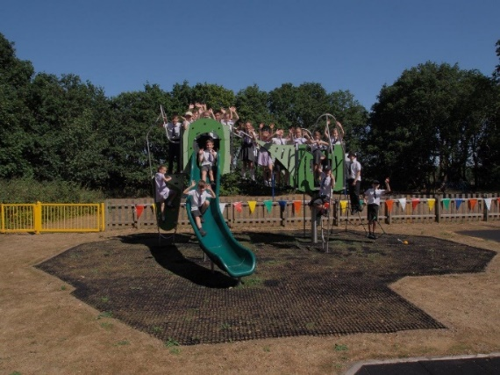

In February 2016 and 2018, 'Money to Play With' consultations sought views on how to spend available funds for 'sports and active play' from the Outdoor Playing Space Fund for Parishes.

A 5km trim trail around Martlesham was completed in 2019, and in 2020, with the help of East Suffolk Council and members of the Martlesham community, the parish council began working on the next phase of consultation, which identified that young people wanted additional equipment in the play area, and somewhere to play football and basketball.

The original play area was unveiled in 1977 and named in honour of The Queen’s Silver Jubilee. The year 2012 then marked the opening of the nearby Diamond Jubilee Bike Trails.

Cabinet approval for festival Public Space Protection Order to be discharged
An order imposed to address the possession and consumption of legal highs at the Latitude Festival has been discharged.

Introduced in 2016, and extended for a further three years in 2019, the Public Space Protection Order (PSPO) for Latitude Festival was due to expire on 17 July 2022.

Earlier this year, partners were consulted and agreed that, while it did have some positive impact, there was insufficient evidence to either extend or vary the order for use at this year’s event.

On 7 June, East Suffolk Council’s Cabinet approved the discharge of the order, which was used by police to issue four fixed penalty notices since 2016.

Night-time economy scheme marks 20 years of serving town
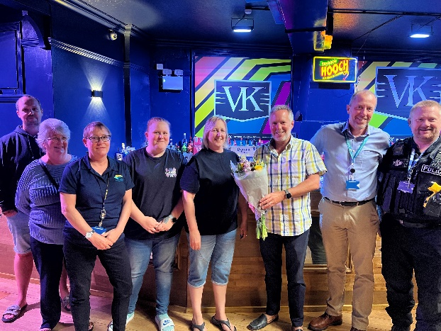 | A group of publicans and licensees have celebrated 20 years of a scheme aimed at keeping their town a safe place for customers to enjoy a night out.  The Felixstowe Nightsafe Partnership was formed in 2002 by a group of licensees and others in the town, supported by Suffolk Constabulary and the East Suffolk Community Safety Partnership.

The scheme’s current membership gathered at The Grand bar and nightclub, in Bent Hill, to mark the anniversary on Thursday 7 July, joined by Cllr Mark Jepson, Community Safety Partnership Chair and Assistant Cabinet Member responsible for Community Safety.

Regular meetings are held to keep members of the Partnership fully informed of any recent incidents and to share best practice.

The Nightsafe banning committee has the power to collectively ban those whose behaviour is or has been unacceptable from all Nightsafe premises. At a recent meeting, the group took a strong stance on a number of individuals, with some being banned for up to five years from premises in Felixstowe.

East Suffolk Council response to Sizewell C development consent
East Suffolk Council acknowledges the recent decision by the Secretary of State for the Department of Business, Energy and Industrial Strategy to grant a Development Consent Order for Sizewell C new nuclear power station promoted by EDF Energy at Sizewell, Suffolk.

The project will provide up to 3.2 GW of low carbon energy once constructed helping achieve the Government’s Net Zero target. This decision which was previously expected in May was delayed to allow further information to be provided by the applicant and interested parties in response to additional post examination consultations.

East Suffolk Council will be reviewing the Examining Authority’s report, Secretary of State’s decision letter and Development Consent Order over the coming days and weeks. These are lengthy documents which contain a significant amount of detailed information regarding the decisions made and the reasoning behind them which will be important to understand.

The project will soon move into a new phase following the decision, with a focus on delivery and discharging the requirements. East Suffolk Council recognises the challenges this will bring as a result of the scale of construction works associated with the development, the provision of the required mitigation and compensation measures in a timely manner will therefore be vital.

More than £350,000 awarded towards North Lowestoft Heritage Action Zone restoration projects this year
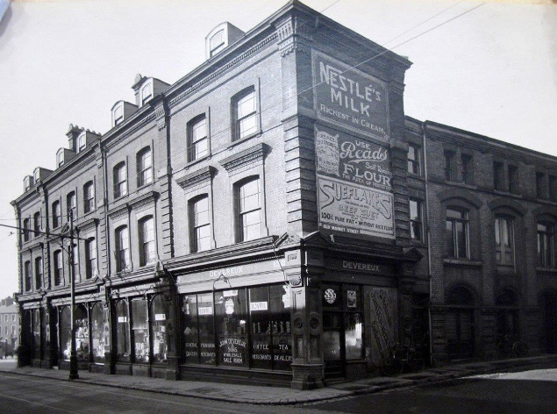 | More than £350,000 of funding has this year been awarded towards a series of renovation projects in the North Lowestoft Heritage Action Zone (HAZ).  Work is currently underway on 11 properties within the North Lowestoft HAZ, which includes the High Street and contains the town’s original main medieval settlement.

The projects are part of the five-year scheme, jointly funded by Historic England and East Suffolk Council, and running in partnership with Lowestoft Town Council, Lowestoft Vision and the East Suffolk Building Preservation Trust from 2018 to 2023.

The funding, from Historic England and East Suffolk Council, will further boost the High Street in the final months of the HAZ scheme – with some of the work already underway at some sites.

Work has just commenced on the former Devereux Stores at 127-130 High Street (pictured), where funding has been provided to repair and replace the original sash windows, following planning approval, to the first and second floor, and to carry out stonework repairs.

Funding for the projects, as part of the North Lowestoft HAZ, came through two grant giving programmes, Partnership Schemes in Conservation Area (PSiCA) and Buildings At Risk, with applicants able to request up to 80% of project costs and required to meet eligibility criteria. A further five privately owned properties have also previously received funding.

Surveys and consultations
As always, we want to encourage participation in surveys and consultations, as feedback from people in East Suffolk is invaluable and helps us ensure we’re making the right decisions for our communities.

- Shadingfield, Sotterley, Willingham and Ellough Neighbourhood Plan
Representations are invited ahead of Saxmundham’s Neighbourhood Plan being submitted for independent examination. Representations must be received 5pm on Wednesday 7 September.

- Lowestoft Railway Station refreshments building public consultation
Proposals for the redevelopment of a derelict part of the station building, detailed within the Lowestoft Town Investment Plan. Open until Friday 9 September.
Social media
We keep our communities up to date in a variety of ways and social media has an important role to play. Please follow us and share our posts with your audiences!
Facebook: www.facebook.com/eastsuffolkcouncil

